**Assignment 1**



**Spring 2025**

**CSE-408 Digital Image Processing**

Submitted by: **Suleman Shah**

Registration No.: **21PWCSE1983**

Class Section: **C**

Submitted to:

**Engr. Mehran Ahmad**

Date:

**21st May 2025**

**Department of Computer Systems Engineering**

**University of Engineering and Technology, Peshawar**

**Activity 1:** Implement thresholding using MATLAB or Python. **Show the code and the output result** (original image and thresholded image).

**Code:**

**  
Output:**

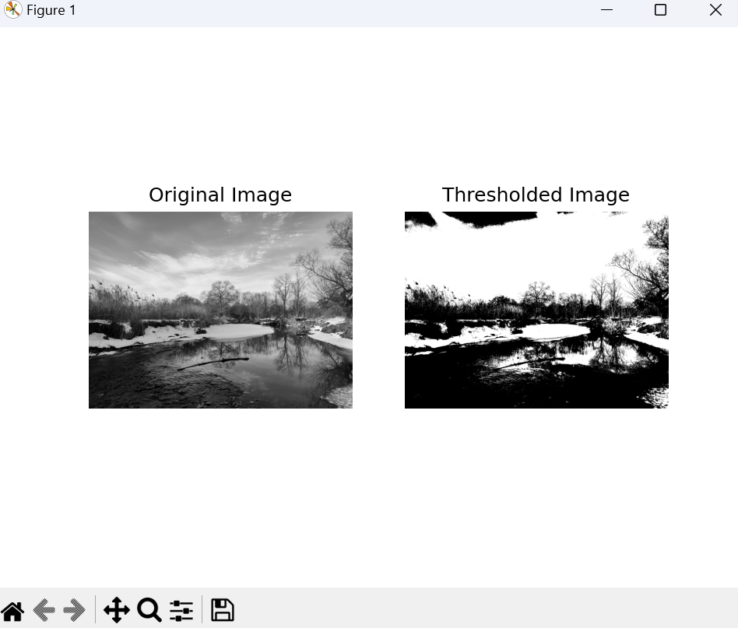

**Activity 2:** Write a MATLAB/Python script to perform negative transformation of an input image. **Show the code and the output result** (original and negative image, along with histograms).

**Code:**

**  
Output:**

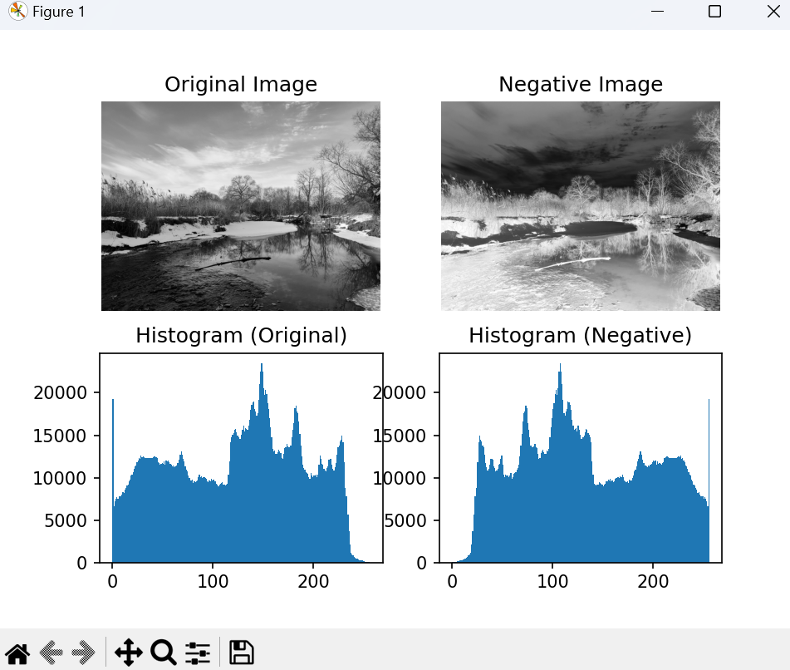

**Activity 3:** Implement a logarithmic transformation in MATLAB/Python. **Show the code and the output result** (original image and log-transformed image).

**Code:**

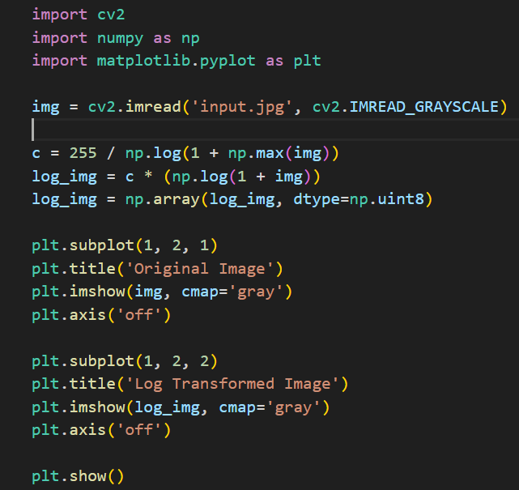

**Output:**

**Activity 4:** Write MATLAB code to apply a power-law transformation on an image using different values of *γ*. **Show the code and the output result** (original image and transformed images for various γ values).

**Code:**

**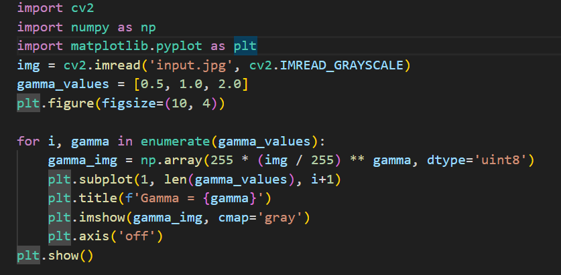  
Output:**

